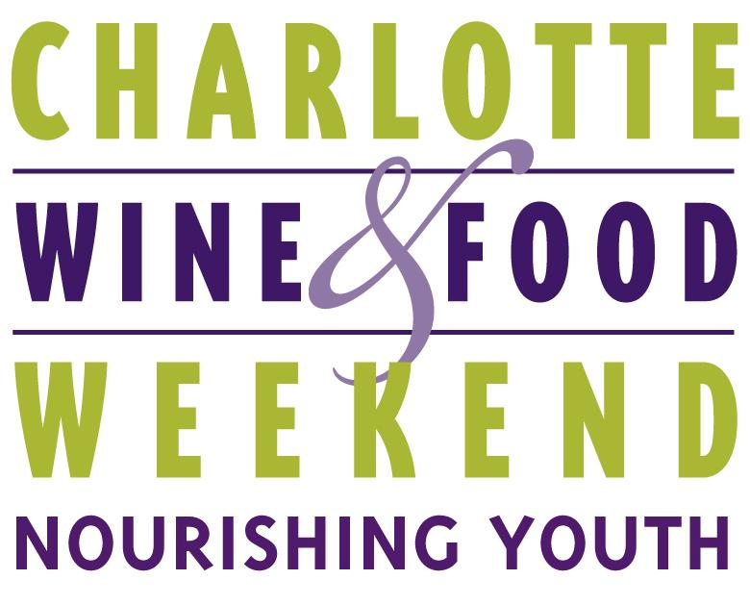

Contact Foster Whitney O’Brien  Phone 704-338-9463  Email fobrien@charlottewineandfood.org  Website www.charlottewineandfood.org | FOR IMMEDIATE RELEASE  June 6, 2018

CHARLOTTE WINE & FOOD WEEKEND DONATES $250,000
TO LOCAL CHILDREN’S CHARITIES
A true celebration of fine wine and food for an even greater cause
Charlotte, NC (June 6, 2018) – Charlotte Wine & Food Weekend Board Chairman Phil Smith announced Wednesday that the organization raised $250,000 for Charlotte-area children’s charities. Checks were presented to the five beneficiaries, Charlotte Concerts, The Council for Children's Rights, Mitchell's Fund, Pat's Place Child Advocacy Center, and The Relatives, in a presentation on June 5, 2018.
"After months of planning, it was so rewarding to see our extensive series of events come together, and to feel the strong support of the Charlotte community around our organization and our mission. It takes a village to make this event a success, from winemakers and distributors, to restaurant and chefs, corporate sponsors, volunteers, donors, staff and board members. It was a thrilling ride for my first year as Executive Director and I cannot wait to see how we'll build on this year's success, next year and beyond," says Lauren Deese, Executive Director of Charlotte Wine & Food Weekend.
Charlotte Wine & Food Weekend was held April 18-21, 2018. For CWFW’s thirtieth year of fundraising, attendees were delighted by an array of events that included signature CWFW staples with a fresh twist: in-home dinners, restaurant/vintner dinners, the 1000-Point Tasting, a Grand Tasting with silent auction and Grand Gala with live auction. Residents and visitors of Charlotte had the opportunity to try over 100 different types of wines paired with food from the city’s hottest culinarians, and bid on live and silent auction items and once-in-a-lifetime experiences – all to raise awareness and money for five Charlotte-based children’s charities focusing on Nourishing Youth and Children in body, mind and spirit.
The CWFW team has a busy summer schedule planning for the year ahead. Save the date for next year’s event series April 24-27, 2019, and be on the lookout for exciting announcements regarding CWFW’s Bank of America Fall Favorites Dinner taking place in October and the Wells Fargo Kick-off Dinner in early 2019. Patrons should expect Fall Favorites tickets to go on sale in late summer. Sponsorship and volunteer opportunities are available for every CWFW event, and those interested are encouraged to email info@charlottewineandfood.org or call the office at (704) 338-9463.
# # #
ABOUT CWFW
Charlotte Wine & Food Weekend brings together leading winemakers and chefs from around the world to celebrate and advance appreciation for great wine and food, while making significant contributions to charitable organizations that benefit children and their families in the Charlotte community.
If you would like more information about this topic, please contact Foster Whitney O’Brien at 704-338-9463 or email at fobrien@charlottewineandfood.org.

