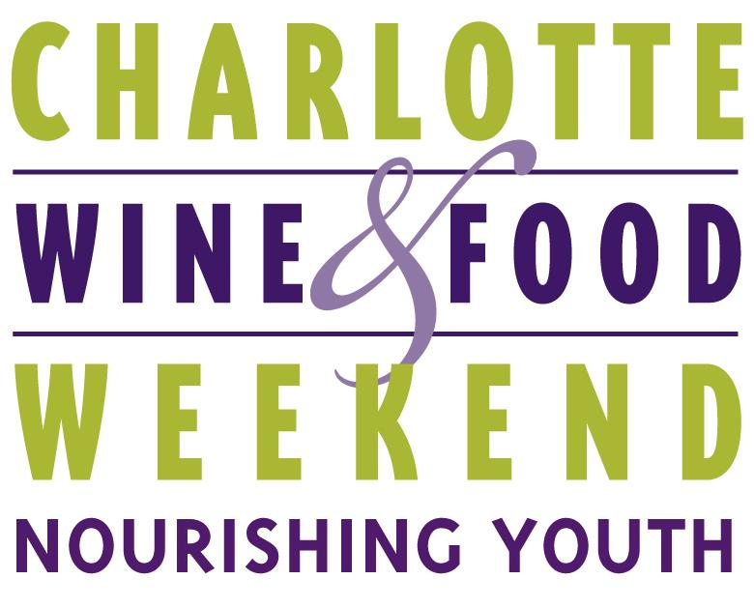

CONTACT:
Foster Whitney O’Brien
fobrien@charlottewineandfood.org
704-338-9463

FOR IMMEDIATE RELEASE

CHARLOTTE WINE & FOOD RAISES $38,000
FOR LOCAL CHILDREN’S CHARITIES
A celebration of fine French wine and food for an even greater cause

Charlotte, NC (September X, 2018) – Charlotte Wine & Food Weekend (CWFW) Board Chairman Phil Smith announced on Monday, September 24, that the organization raised $38,000 for Charlotte-area children’s charities at Icons of Burgundy + Champagne held on Wednesday, September 19, in uptown Charlotte, NC. Proceeds from the special pop-up event will benefit the non-profit’s five charity partners: Charlotte Concerts, The Council for Children's Rights, Mitchell's Fund, Pat's Place Child Advocacy Center, and The Relatives.

The two-part event included a tasting and dinner that featured 17 different wines by iconic French wineries Bouchard Père & Fils and Champagne Henriot with wine education led by special guest Gilles de Larouzière, President of Maisons & Domaines Henriot. The tasting was held with generous support from Barings in the private Sky Room atop the Barings building and the six-course wine-pairing dinner, prepared by Executive Chef Michael Rouleau, took place at La Belle Helene immediately following the tasting. Guests bid on live auction items and experiences including a priceless trip for four to stay at the Le Château de Beaune in Burgundy donated by Maisons & Domaines Henriot.

A sister event was hosted the following evening at Linville Ridge Country Club and included a second priceless trip for four to Burgundy sold at a live auction with all proceeds going to CWFW charity partners as well as the sale of a rare Bouchard Père & Fils Grand Cru Le Corton Domaine 2003 with proceeds going hurricane relief in North Carolina.

“It was an honor and privilege for us to host two iconic French wineries and we are overwhelmed by their benevolent support of our goal to increase our giving for CWFW’s 2018-2019 cycle. Thanks to our partners, Barings, La Belle Helene, Maisons & Domaines Henriot, Linville Ridge Country Club and The Wine Vault, for helping us make this momentous event a success! And we would like to especially thank Chairman Emeritus David Furr, for his service in spearheading this exciting evening as well as Board Members Brian Poplin and David Secrest for their individual contributions." said Lauren Deese, Executive Director of Charlotte Wine & Food Weekend.

Save the date for CWFW’s next events including the Bank of America Fall Favorites Dinner featuring the Best of The Spire Collection on Thursday, November 8, 2018, and the Wells Fargo Kickoff Dinner featuring Vega Sicilia on Thursday, January 31, 2019. Sponsorship and volunteer opportunities are available for every CWFW event, and those interested are encouraged to email info@charlottewineandfood.org or call the office at (704) 338-9463.

# # #

ABOUT CWFW
Charlotte Wine & Food Weekend brings together leading winemakers and chefs from around the world to celebrate and advance appreciation for great wine and food, while making significant contributions to charitable organizations that benefit children and their families in the Charlotte community.

For more information, please contact Foster Whitney O’Brien at 704-338-9463 or fobrien@charlottewineandfood.org.

