NEWS Media Contact

FOR IMMEDIATE RELEASE Michelle Harden
704-338-9463
mharden@charlottewineandfood.org

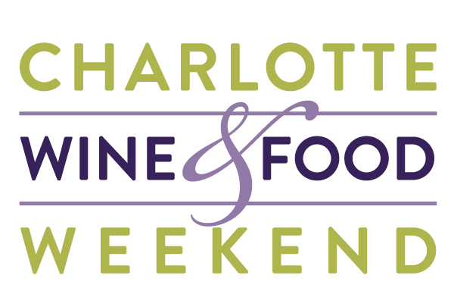

TICKETS NOW ON SALE FOR #CharlotteWineAndFood2019
Join Charlotte’s annual celebration of fine wine and food for an incredible cause
Charlotte, N.C. (February 21, 2019) – Charlotte Wine & Food Weekend (CWFW) is elated to announce tickets are officially on sale for their four-day experience of fine wine and food benefitting children in the community.
The 31st year of CWFW will be held Wednesday, April 24, through Saturday, April 27, 2019, in various private homes, restaurants, and event venues around Charlotte. Attendees will taste an array of fine wines paired with refined food from the city’s hottest chefs, while supporting five child-focused charities in Charlotte through live and silent auctions featuring exclusive wine lots, dining and travel experiences, and other exciting packages.
“We are thrilled to announce our exciting line-up of events for what we hope to be the best year yet for Charlotte Wine & Food Weekend,” says Lauren Deese, Executive Director of CWFW. “We are privileged to have some of the world’s leading vintners and somms joining us as we pair them up with the best of Charlotte’s culinary talent. In addition, we are thrilled to have a few of our most loyal CWFW partners return, like Kelley Jones, President of The Spire Collection; and Laura Maniec, Master Sommelier and proprietor of Corkbuzz; but we are also welcoming some new names to the event for the first time such as the legendary Fred Dame, MS joining us with Daou Vineyards; DLynn Proctor, Winery Director with Fantesca Estate & Winery and subject of the movie “Somm;” and Tom Rozner, VP of Hartford Family Winery, to name a few.”
Events include CWFW staples including private in-home dinners, restaurant/vintner dinners, a Grand Tasting with silent auction, educational seminars and the ever-popular 1000-Point Tasting newly expanded into the Lucky 13 Experience.
The Lucky 13 Experience, limited to 60 very lucky guests, starts with a 1000-Point Tasting hosted and curated by CWFW Chairman Emeritus David Furr and special guest Kelley Jones, President of The Spire Collection, all set high atop the Barings’ building uptown in their state-of-the-art Sky Room. Following the tasting, after a brief alfresco stroll through uptown, the festivities will resume at the private dining room of Aria Tuscan Grill with a 300-point Italian wine dinner and a live auction featuring the best wine and experience lots CWFW has to offer. As our grand finale of the 2019 “Weekend” event series, this is the ultimate wine connoisseur’s tour de force!
The Grand Tasting and Silent Auction on Friday, April 26, will bring together 100 wines from around the world and mouthwatering bites from Charlotte’s top culinary artisans being held for the second year at the Atrium at Two Wells Fargo Center. A special early bird discount of $15 off Grand Tasting tickets will be available through March 1, while supplies last.
“The beauty of our events is there is something for every taste,” says Deese. “All we ask is that you bring your appetite, a desire to learn and delight your palate, and a willingness to make a difference in the lives of others.”
# # #
Participating Vintners include Benevolent Neglect, Broadbent Selections, Casa Lapostolle, Dalla Valle Vineyards, Daou Vineyards, Domaine Paul Jaboulet Aîné, Duckhorn Vineyards, Fantesca Estate & Winery, Huneeus Vintners, Hartford Family Winery and Hartford Court, Paul Hobbs Winery, Rombauer and The Spire Collection.

In addition, participating Restaurants include Bardo, BLT Steak, Bulla Gastrobar, Corkbuzz Restaurant & Wine Bar, Fin & Fino, FR Custom Catering, Hawkers Asian Street Food, Mimosa Grill, Napa on Providence, Oak Steakhouse, Porcupine Provisions, Stoke, Sweet Lew’s BBQ, Swirl, The Capital Grille, The Fig Tree Restaurant, Upstream, WP Kitchen + Bar, and Zinicola.

Charlotte Wine & Food Weekend would like to extend special thanks to supporting corporate sponsors Bank of America, Grand Thornton, SunTrust, Wells Fargo, Ally Financial, Foreign Cars Charlotte, Celebrity Cruises, EY, KPMG, Morrison Smith, Porcupine Provisions, and Wine Vault. Thank you to our media sponsors Craveable Carolinas, The Local Palate, and M2 Public Relations. Last but not least, Charlotte Wine & Food Weekend is a proud partner of CLT250.

Tickets are available for purchase starting Thursday, February 21, at noon at charlottewineandfood.org. A schedule preview will launch Wednesday afternoon. Sponsorship and volunteer opportunities are also still available, and those interested are encouraged to email info@charlottewineandfood.org, or call the office at (704) 338-9463 (WINE).
# # #
ABOUT CHARLOTTE WINE & FOOD WEEKEND
Charlotte Wine & Food Weekend brings together leading winemakers and chefs from around the world to celebrate and advance public knowledge of and appreciation for great wine and food, while making significant contributions to charitable organizations that benefit children and their families in the Charlotte community.

Charlotte Wine & Food Weekend's charitable endeavors focus on Nourishing Youth and Children, nurturing the whole child in body, mind and spirit. The beneficiaries of the 2019 Charlotte Wine & Food Weekend are: Charlotte Concerts; The Council for Children's Rights; Mitchell's Fund; Pat's Place Family Advocacy; and The Relatives.

If you would like more information about the event, please contact Michelle Harden at 704-338-9463 or mharden@charlottewineandfood.org.

