Contact | Michelle Harden
Telephone | 704-338-9463
Email | mharden@charlottewineandfood.org
Website | www.charlottewineandfood.org

FOR IMMEDIATE RELEASE

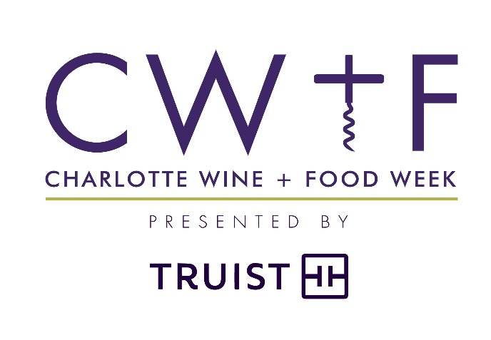

Charlotte Wine + Food
ANNOUNCES FUNDS RAISED FROM 2021 EVENTS
$200,000 donated to four local children’s charities
Charlotte, N.C. (June 24, 2021) – Charlotte Wine + Food (CW+F) Board Chairman Palmer Steel announced Wednesday, June 23 that following the culmination of Charlotte Wine + Food’s 33rd year of fundraising, the organization would be making a distribution of $200,000 to Charlotte-area children’s charities. Checks were presented to the four beneficiaries, GenOne, Mitchell’s Fund, The Learning Collaborative, and The Relatives, at a Check Presentation Celebration on June 23, 2021 held at Cork Vault.
"Our check presentation celebration is always the best day of the year, but even more so after a challenging year that presented difficulties in fundraising and scaled back events,” says Lauren Deese, Executive Director of Charlotte Wine + Food. Deese continues to say, “We were thrilled to have been able to gather once again, to rebuild momentum, and to continue uplifting and supporting the less fortunate children in our community. We are grateful for the outpouring of support received from our incredible network of patrons - vintners and distributors, restaurants and chefs, retailers, corporate sponsors, volunteers, individual donors, staff, and board members – whose support resulted in a fundraising outcome in line with pre-covid levels. Together we have made an indelible impact on so many lives.”

Charlotte Wine + Food Week presented by Truist was held Wednesday, April 14, through Sunday, April 18. Attendees were delighted by an array of events that included signature CW+F staples and new offerings: private in-home dinners, restaurant vintner dinners including a new high-end sake dinner at Baku, an Online E-Auction open to the public, our first-ever Rosé Brunch hosted on the beautiful patio of the historic uptown house now home to Poplar Tapas, Wine & Spirits, and a 2020 Winemaker Honoree Pop-Up Dinner ft. renowned Napa Valley Winemaker Julien Fayard held at Bardo.
Proceeds from the 2021 events will help each of our charity partners continue their own missions.
GenOne partners with talented, first-generation students from under-served communities, helping them successfully navigate to and through college. GenOne provides the social capital and resources needed to equalize the incredible resource gap found between first-generation students in poverty and their affluent peers. They help to break cycles of generational poverty in Charlotte, N.C., a city that ranks 50/50 in Upward Social Mobility. 100% of their senior class was accepted to 4-year colleges and 67% will attend debt free. They will use the funds to maintain their staff who coordinate college access services and provide these crucial resources.

Mitchell’s Fund seeks to improve mental well-being for children and families who have experienced trauma. They will use funds to help pay the annual salary for a mental health counselor who works with sick children and their families in the St. Jude Affiliate Clinic at Novant Health. The counselor uses play, art and talk therapies to help patients process the shock of diagnosis, the pain and anxiety of treatments and, in some cases, helps them prepare for the end of life. In 2020, the counselor worked with over 300 patients and their families.

The Learning Collaborative (TLC) is a high-quality, tuition-free preschool located in Charlotte’s fragile Grier Heights neighborhood serving children living in poverty. They provide an early educational intervention for 72 children ages 2-5, as well as educate and empower their parents through their Family Support and Involvement program. Funds raised through Charlotte Wine + Food’s efforts support TLC’s classroom operations, making it possible for them to guide and support each child as they progress towards school readiness. With the pandemic behind them, TLC is expecting to be at full capacity enrollment for the upcoming school year in each of its five classrooms.

Each year, The Relatives provides over 5,000 youths and young adults with relief in place of despair, acceptance in place of rejection and empowerment in place of helplessness. The pandemic increased the needs of those who rely on The Relatives and presented a fundraising challenge for the organization. The Relatives will use the Charlotte Wine + Food Week proceeds towards their general operating budget, ensuring youth facing crisis can find safety and stability.
Charlotte Wine + Food is in the planning stages of its next events. Save the date for next year’s Charlotte Wine + Food Week presented by Truist to take place April 27-May 1, 2022. Sponsorship opportunities are available for every CW+F event, and those interested are encouraged to email info@charlottewineandfood.org or call the office at (704) 338-9463.
The 2021 - 2022 charity beneficiaries include the following children’s charities: GenOne, The Learning Collaborative, and two additional charity partners that are currently being selected by a committee of CW+F board members and will be announced this fall at our upcoming kickoff event.
# # #
ABOUT CHARLOTTE WINE + FOOD
Charlotte Wine + Food brings together leading wine industry experts from around the world and pairs them with Charlotte’s top chefs to celebrate and advance public knowledge of and appreciation for fine wine and food, while making significant contributions to charitable organizations that benefit children and their families in the Charlotte community.
Charlotte Wine + Food is a non-profit 501(c)3 directed by a fellowship of wine and food connoisseurs that make up its volunteer board of directors. All events benefit strategically selected charity partners that support children and their families in the local community.

