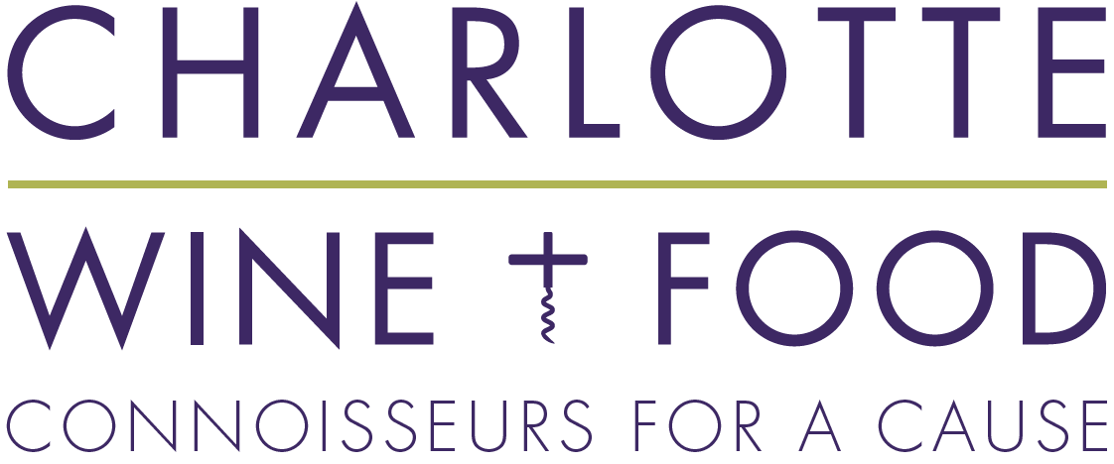
Contact Michelle Harden  Telephone 704-338-9463  Email mharden@charlottewineandfood.org  Website www.charlottewineandfood.org | FOR IMMEDIATE RELEASE

Charlotte Wine & Food Week Presented by Truist | April 22-25, 2020
Tickets on sale WEDNESDAY, February 26 @ 12:00 pm

Join Charlotte’s annual celebration of fine wine and food all for an incredible cause!
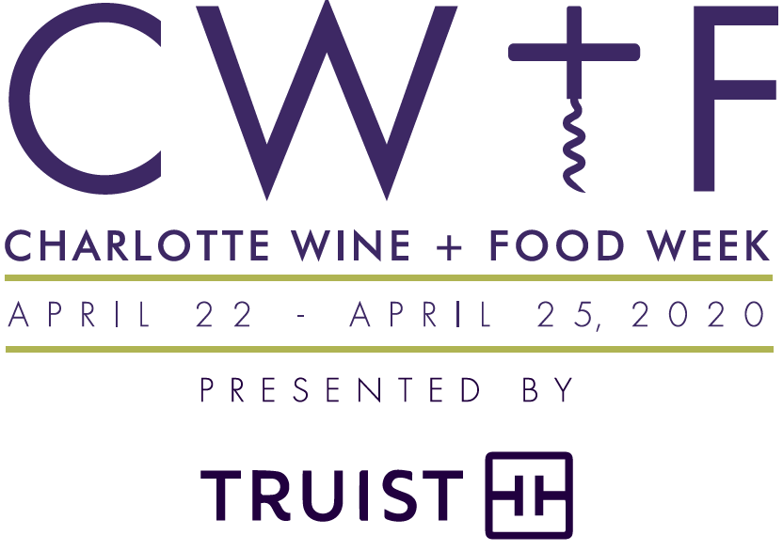
Charlotte, N.C. (February 20, 2020) – Charlotte Wine & Food is thrilled to announce the event schedule for the four-day Charlotte Wine & Food Week (CWFW) presented by Truist (formerly known as Charlotte Wine & Food Weekend) taking place April 22-25, 2020 – an annual celebration of fine wine and food benefiting children in the Charlotte community.
CWFW 2020 events offerings will include annual staples such as private in-home vintner dinners, restaurant vintner dinners, a Grand Tasting with silent auction, educational seminars and the ever-popular 1000-Point Tasting as part of the grand finale experience. All events will benefit four child-focused charities including GenOne, Mitchell’s Fund, The Learning Collaborative, and The Relatives.
The largest event of CWFW, the Grand Tasting and Silent Auction on Friday, April 24, will bring together 100 wines from around the world, a few craft breweries, and mouthwatering bites from over 10 of Charlotte’s top culinary artisans being held for the third year at the Atrium at Two Wells Fargo Center. A special early bird discount of $15 off Grand Tasting tickets will be available while supplies last. New this year, CWFW will also offer a limited number of early admissions tickets allowing savvy connoisseurs the first run to their favorite winery and chef tables.
The Grand Finale: 1000-Point Tasting & Dinner, limited to 70 very lucky guests, starts with a tasting of ten 100-point-rated wines hosted by special guest Laura Maniec-Fiorvanti, Master Sommelier and Proprietor of Corkbuzz who was recently named the ‘Sommelier / Beverage Director of the Year ‘by Wine Enthusiast. Following the tasting, the festivities will resume high atop the Barings’ building uptown in their state-of-the-art Sky Room with a three-course dinner and live auction featuring the best wine and experience lots CWFW has to offer. As our grand finale of the 2020 “Week” event series, this is the ultimate wine connoisseur’s tour de force!
“The beauty of our events is there is something for every taste,” says Deese. “All we ask is that you bring your appetite, a desire to learn and delight your palate, and a willingness to make a difference in the lives of others.”
With this announcement, Charlotte Wine & Food is unveiling its refreshed name and new tagline after taking an extensive look at their brand strategy this past year. Charlotte Wine & Food is officially dropping the “Weekend” and will be known as Charlotte Wine & Food, except when referencing the four-day festival held each April, which will be renamed the Charlotte Wine & Food Week, to account for events taking place outside of just the weekend. The new name also come with a new tagline, “Connoisseurs for a Cause,” to reflect the organization’s long-standing mission of bringing together the wine and food connoisseur community of Charlotte to fundraise for the benefit of children and their families in the community.
Charlotte Wine & Food is also grateful to be supported by a new presenting sponsor for this year’s Charlotte Wine & Food Week, Truist, the newly merged BB&T and SunTrust. The impact of their support will go a long way in meeting Charlotte Wine & Food’s fundraising goals for this year.
“Truist is honored to serve as the presenting sponsor of the 2020 Charlotte Wine & Food Week,” said Heath Campbell, President of the Charlotte-Metrolina Region. “We are excited that Charlotte is our new headquarters and passionate about partnering with organizations like Charlotte Wine & Food that are part of the fabric of our community.”
Tickets ($75-$500) will be available for purchase starting Wednesday, February 26 starting at noon at charlottewineandfood.org. An event schedule preview will launch Tuesday, February 25 in the afternoon.
# # #
Participating vintners at time of release include Bodega Catena Zapata, Broadbent Selections, Chappellet, DAOU Vineyards, Dunn Vineyards, Ellman Family Vineyards, E. Guigial, Guillaume Gonnet Vigneron, Long Meadow Ranch, Orin Swift, Palhmayer, Raffaldini, Roy Estate, Scale Wine Group, Stonestreet Estate Vineyards, and The Spire Collection.

Participating restaurants and caterers at time of release include include Bardo, Barrington’s, Belmont’s Specialty Foods, BLT Steak, Bonterra Dining & Wine Room, Corkbuzz Restaurant & Wine Bar, Deejai Thai, Dish, Dot Dot Dot, Fin & Fino, Francie & Co., Indaco, Napa on Providence, Noble Food & Pursuits, Petit Philippe, Porcupine Provisions, Reid’s Fine Foods, Seasoned Provisions, Stagioni, Stoke, Sweet Lew’s BBQ, Swirl, and The Fig Tree.

Charlotte Wine & Food would like to extend special thanks to its sponsors
Presenting Sponsor: Truist
Grand Cru Sponsors: Bank of America, Wells Fargo
Premier Cru Sponsors: Ally Financial, Celebrity Cruises, EY, Foreign Cars Charlotte, KPMG, Marty Snider & Associates, Porcupine Provisions, Scope Anesthesia, The Plaid Penguin, and The Wine Vault
In-Kind Sponsors: Barings, Cork Vault, Fiji Water, Morrison Smith Jewelers
Media Sponsors: The Local Palate and M2 Public Relations

Sponsorship and volunteer opportunities are also still available, and those interested are encouraged to email info@charlottewineandfood.org, or call the office at (704) 338-9463 (WINE).

# # #
ABOUT CHARLOTTE WINE & FOOD
Charlotte Wine & Food brings together leading wine industry experts from around the world and pairs them with Charlotte’s top chefs to celebrate and advance public knowledge of and appreciation for fine wine and food, while making significant contributions to charitable organizations that benefit children and their families in the Charlotte community.
Charlotte Wine & Food is a non-profit 501(c)3 directed by a fellowship of wine and food connoisseurs that make up its volunteer board of directors. All events benefit strategically selected charity partners that support children and their families in the local community. The beneficiaries for Charlotte Wine & Food’s 2019-2020 fiscal are GenOne, Mitchell’s Fund, The Learning Collaborative, and The Relatives.

BRIEF EVENT LISTING COPY

Charlotte Wine & Food Week (CWFW) presented by Truist | April 22-25, 2020
Oenophiles of all kinds – from casual sippers and samplers to serious connoisseurs and collectors – will have four days to celebrate the nectar of the gods at the Charlotte Wine & Food Week presented by Truist. Attendees of this cherished Charlotte cultural institution will not just be imbibing the world’s finest wines, savoring the creations of the area’s top chefs, hobnobbing with renowned vintners and somms, adding to their wine knowledge, and bidding on fantastic one-of-a-kind items, they will also be helping area children. Proceeds for 2020 benefit four local children’s charities; GenOne, Mitchell’s Fund, The Learning Collaborative and The Relatives. To purchase tickets or to sign up for our email notifications about events, visit charlottewineandfood.org.

